SOP – thrift plus member lookup
If a customer indicates that they are a thrift plus member already, select the “Thrift + member” option in Dash:
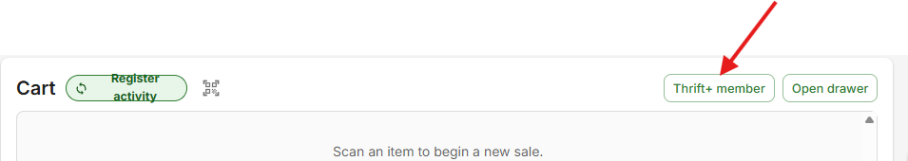

If they have their QR code ready and available you can scan it at this point. If they don’t have their QR code ready to scan, don’t worry about having them try to find it, we can use their phone number to find their account. On the following screen type the member’s phone number in the open field
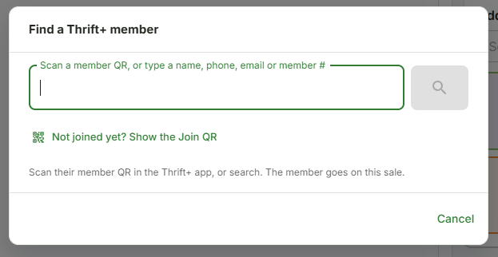
As you can see there are several ways to look up a member so if they are sure they’ve signed up but the phone number doesn’t find them, you may try any of the other options, name, email, or member ID but phone number is usually the easiest. If none of the options bring up the member, go ahead and have them sign up. They can scan the QR code on the printout at register one or they can scan the one from the store phone.
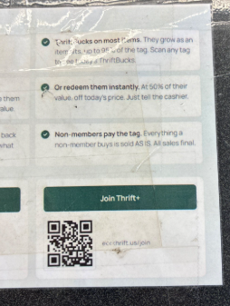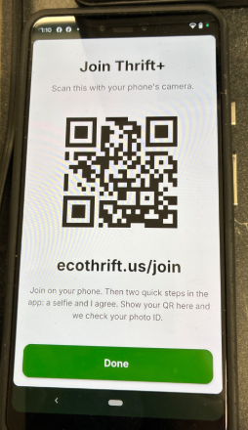

After they fill out their information and take their selfie (for security), it will show them a QR code for us to scan. You can scan this at any point during the transaction to ring them up as a member, there is no need to void any previously rung items or do anything like that. Just make sure you check the upper right hand of the screen in Dash and if the option appears select “member is here”. This will allow them to use any previously earned thrift bucks as well as adding any newly earned thrift bucks to their account. Additionally any store credit they’ve received for returns or any other reasons will also appear here. Remember to always remind the customer that they have 30 days to use their thrift bucks or they will lose them. This area of your screen will tell you the date the customer’s thrift bucks expire.

